Software Development (SDEV) Group   
Quality Indicators and Metrics Report

for Q1, 2025

Created 2025-05-29

1. **Purpose**

This report provides quarterly metrics data for the Bioinformatics Software Development (SDEV) group’s production processes and activities.

1. **Metrics**

Metrics collected from JIRA are from the Software Development (SDEV), Genomic Report (GERO), and MAVIS (MAV) projects.

## Metric #1

|  |  |
| --- | --- |
| Title | **Production Open/Close Rate** |
| Metric’s purpose | The purpose of this metric is to measure SDEV team’s capacity for reviewing and integrating new code into our production pipeline. When assessing this measure, the general trend matters more than the specific numbers. |
| Data | Q1, 2025: January 1 to March 31  We measure the number of production tickets (excluding bugs) that are opened and closed within a specific time period. This measure is collected using JIRA dashboard and reporting tools. |
| Acceptance Criteria | Like the previous metric, this is a relative measurement and therefore only valuable when compared to measurements collected over time. Assuming the capacity of the SDEV team will not change significantly over time (near constant capacity), a higher ratio can be an indicator of more efficient work, higher throughput, and reduced lead time. |
| Analysis and Findings | As shown in Figure 1, the ratio of closed task tickets to opened ones in the first quarter of 2025 is calculated as follows:  141 / 111 * 100% = 127.0%  The Open/Close Rate for task tickets was greater than 100%, which indicates the backlog of task tickets shrunk this quarter. |

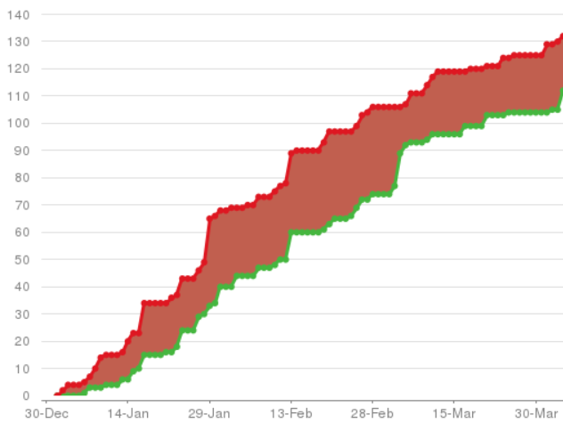

**Figure 1.** Number and trend of responsiveness for all tickets created for the SDEV team in the first quarter of 2025. Red is the cumulative number of tickets created and green is the cumulative number of tickets resolved.

## Metric #2

|  |  |
| --- | --- |
| Title | **Bug Open/Close Rate** |
| Metric’s purpose | We would like our software to never fail. However, achieving such a goal is statistically improbable. It is hence our purpose to ensure that when our software fails, we can instantly recover. The number of bug tickets that are reported and closed within a specific time period allows us to measure the reliability of our pipelines and assess our responsiveness in fixing reported issues. This metric does not provide any information about individual affected features or users. |
| Data | Q1, 2025: January 1 to March 31  We measure the number of JIRA bug tickets that are reported and closed within a specific time period. The general trend matters more than the specific numbers. These numbers are collected using the JIRA dashboard and reporting tools. |
| Acceptance Criteria | It is our goal to keep the average number and the standard deviation of reported bugs reasonably low. Historic numbers are also considered when analyzing these results. In general, the larger the ratio of closed to opened bug tickets, the better. |
| Analysis and Findings | As shown in Figure 2, the ratio of closed bug tickets to opened ones in the first quarter of 2025 is calculated as follows:  49 / 44 * 100% = 111.4%  The Open/Close Rate for bug tickets was greater than 100%, which indicates the backlog of bug tickets shrunk this quarter. |

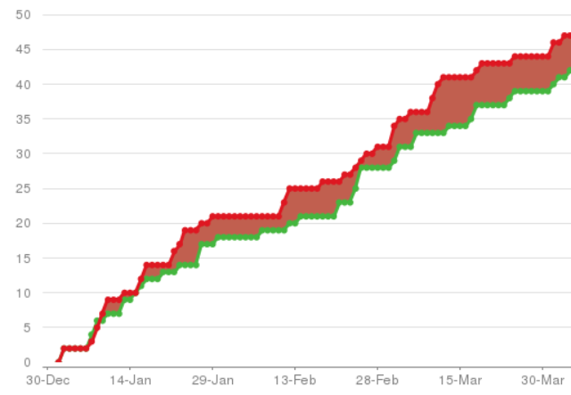

**Figure 2.** Number and trend of responsiveness for bug tickets created for the SDEV team in the first quarter of 2025. Red is the cumulative number of bug tickets created and green is the cumulative number of bug tickets resolved.

## Metric #3

|  |  |
| --- | --- |
| Metrics title | **Lead Time** |
| Metric’s purpose | Lead Time is the amount of time it takes the SDEV team to go from an idea to delivered software. If we want to be more responsive to our clients (increased production Close/Open rate), we need to reduce our Lead Time. Lead Time is similar to Cycle Time, with the difference being that Lead Time measures from when an issue is logged until work is completed (whereas Cycle Time measures from when work began on the issue). |
| Data | Q1, 2025: January 1 to March 31  SDEV uses the ‘JIRA Software Development’ workflow, meaning Lead Time starts when an issue is in ‘Backlog’ and ends when it transitions to ‘Delivery’ or ‘Done’. This measure is collected using JIRA dashboard and reporting tools. Non-working days are not included in the calculation. |
| Acceptance Criteria | Like other metrics presented here, Lead Time is a relative measure and is only meaningful when compared with other measurements recorded over a long time period. In general, SDEV strives to reduce its Lead Time. Therefore, the lower this measurement, the better. |
| Analysis and Findings | As shown in Figure 3, the average Lead Time for *186* SDEV tickets in the first quarter of 2025 is *29 days 16:29:11*. In this time period, the minimum Lead Time was *00:03:52* and the maximum was *8200:13:27*. |

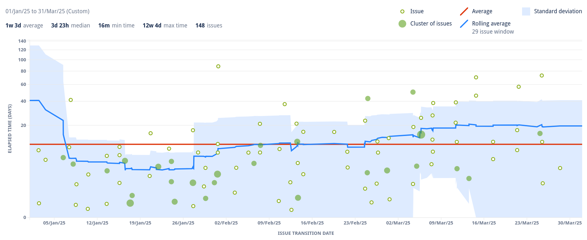

**Figure 3.** Average Lead Time (red line) for SDEV team in the Q1 of 2025.

## Metric #4

|  |  |
| --- | --- |
| Metrics title | **Cycle Time** |
| Metric’s purpose | Cycle Time is the time spent working on an issue. Specifically, it is the length of time between when work begins (‘Backlog’ → ‘Specify’) to when work is completed (‘Delivery’ → ‘Done’), though this may also include any other time spent working on the issue. For example, is an issue is reopened, worked on, and completed again, then the time for this extra work is added to the Cycle Time. Cycle Time restricts the concept of process time to the time spent on tasks that are adding value to whatever is being processed (*i.e.,* specification, implementation, validation, and delivery). |
| Data | Q1, 2025: January 1 to March 31  SDEV uses the ‘JIRA Software Development’ workflow, meaning Cycle Time starts when an issue is in ‘Specify’ and ends when it transitions to ‘Delivery’ or ‘Done’. This measure is collected using JIRA dashboard and reporting tools. Non-working days are not included in the calculation. |
| Acceptance Criteria | Like Lead Time and the other metrics presented here, Cycle Time is a relative measure. In general, declining Cycle Time is desirable. |
| Analysis and Findings | As shown in Figure 4, the average Cycle Time for 142 SDEV tickets in the first quarter of 2025 is *18 days 12:35:46*. In this time period, the minimum Cycle Time was *00:00:04* and the maximum was *384 days 05:09:15*. |

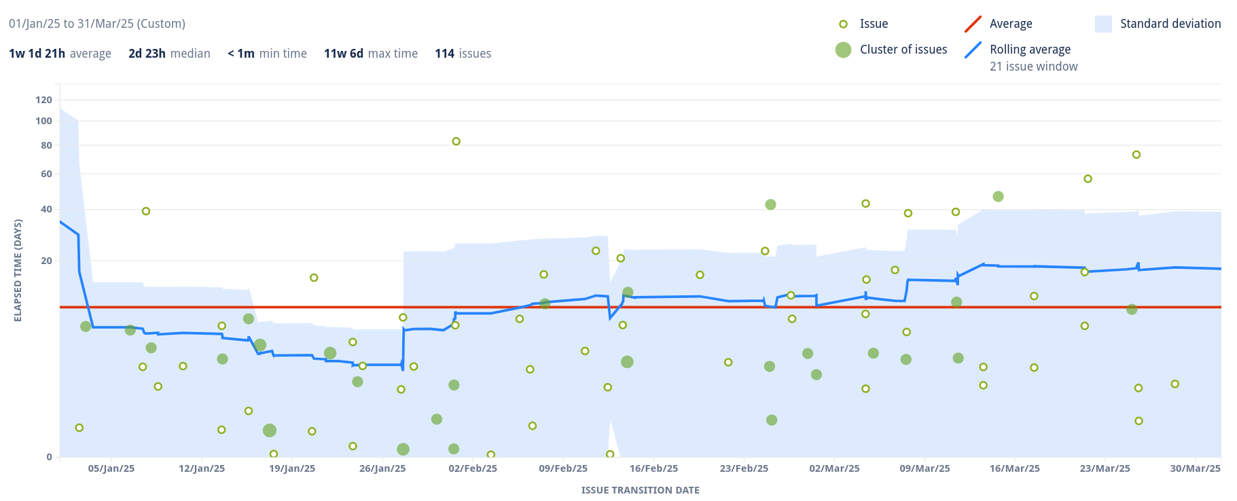

**Figure 4.** Average Cycle Time (red line) for SDEV team in the Q1 of 2025.

## Metric #5

|  |  |
| --- | --- |
| Metrics title | **Rolling Average** |
| Metric’s purpose | As part of our analysis, we look at the rolling average of Lead and Cycle times. The rolling average is an additional measure of process time that does not deviate as sharply towards outliers (when an appropriate number of issues are used to calculate this value). |
| Data | Q1, 2025: January 1 to March 31  This measure is collected using JIRA dashboard and reporting tools. |
| Acceptance Criteria | In general, a decreasing rolling average indicates process improvements and increasing throughput. |
| Analysis and Findings | The rolling average for Lead Time was between *2.8* and *40.8* days, and for Cycle Time it was between *2.1* days and *40.5* days. |

## Metric #6

|  |  |
| --- | --- |
| Metrics title | **Task Completion Rate (TCR)** |
| Metric’s purpose | Task Completion Rate (TCR) tracks tasks completed per day. TCR is the number of tickets that are completed (*i.e.,* the ticket is ‘Closed’) divided by the number of working days within the quarter. TCR is not necessarily the reciprocal of Cycle Time (*i.e.* the average time required to complete a ticket) as it accounts for all the team members and all steps, including the specification step. When compared with TAR (Task Addition Rate) this measure can help us with providing expected completion dates. |
| Data | Q1, 2025: January 1 to March 31  This measure is collected using JIRA dashboard and reporting tools. |
| Acceptance Criteria | Like most of the metrics in this report, TCR is a relative measure. Though, increased TCR is always desirable. |
| Analysis and Findings | Figure 5 illustrates the number of tickets completed over the first quarter of 2025. TCR for the first quarter of 2025 is calculated as follows:  155 / 63 (working days) = 2.5  TCR was less than TAR this quarter, which indicates an overall increase in the number of SDEV tickets in backlog. |

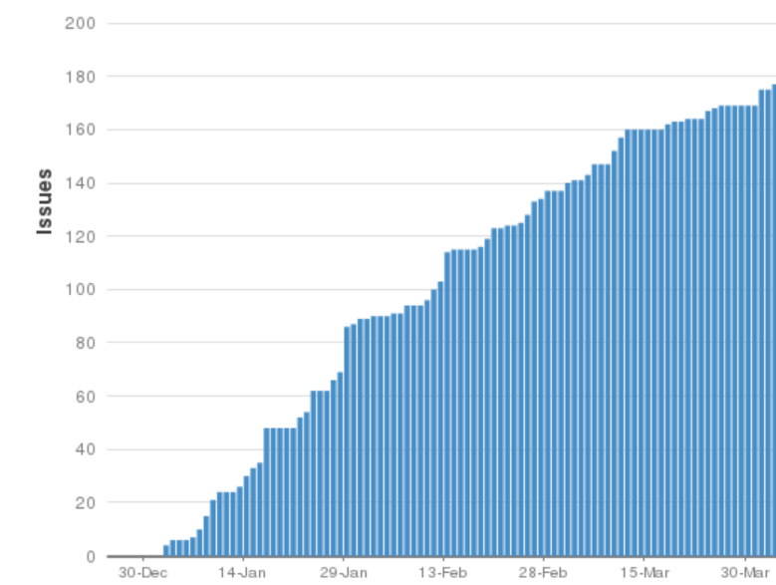

**Figure 5.** Number of tickets completed in each working day during the Q1 of 2025.

## Metric #7

|  |  |
| --- | --- |
| Metrics title | **Task Added Rate (TAR)** |
| Metric’s purpose | The Task Added Rate (TAR) is the number of issues opened per day (or “task cut per day” if the value is negative). To calculate TAR, we subtract the total number of tickets (pending, active, or done) at the start of the quarter from the total number at the end of the quarter and divide it by the number of working days. TAR helps us account for plan changes and feature bloat, as well as assess the current capacity of the SDEV team. |
| Data | Q1, 2025: January 1 to March 31  This measure is collected using JIRA dashboard and reporting tools. |
| Acceptance Criteria | On its own, TAR is not a performance measure. When compared with TCR (Task Completion Rate) however, it can help us with providing expected completion dates. |
| Analysis and Findings | Figure 6 illustrates tickets added over the first quarter of 2025. TAR is calculated as follows: 190 / 63 (working days) = 3.0  TAR exceeded TCR this quarter, which indicates an overall increase in the number of SDEV tickets in backlog. |

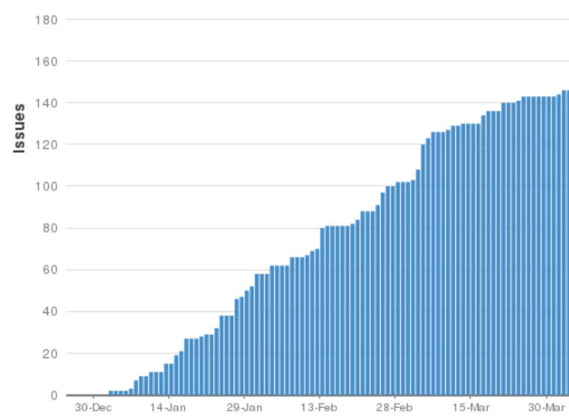

**Figure 6.** Number of tickets added in each day during the Q1 of 2025.

## Metric #8

|  |  |
| --- | --- |
| Metrics title | **Predictability** |
| Metric’s purpose | Predictability is the amount of variation of the actual data from the rolling average. The standard deviation gives an indication of the level of confidence that we can have in the provided completion estimates given by SDEV team management. For example, a low standard deviation makes us confident that the Cycle Time of future issues will be close to the rolling average; hence the estimated completion date will be closer to the actual date. |
| Data | Q1, 2025: January 1 to March 31  This measure is collected using JIRA dashboard and reporting tools. |
| Acceptance Criteria | We aim to narrow standard deviation thorough process improvements to increase the predictability of cycle time. |
| Analysis and Findings | As shown in Figure 7, the standard deviation of Cycle Time fluctuated between *3.4* and *84.9* days. |



**Figure 7**. Pattern of standard deviation for SDEV team's Cycle Time in the Q1 of 2025.

## Metric #9

|  |  |
| --- | --- |
| Metrics title | **Outliers** |
| Metric’s purpose | We identify and analyze outliers to assess their cause and effect on the metrics reported here. |
| Data | Q1, 2025: January 1 to March 31  This measure is collected using JIRA dashboard and reporting tools. Outlier issues are labeled with ‘outlier’ in JIRA.  Outliers are typically tickets that are not actively worked on for prolonged periods of time (multiple months) without being put on hold or closed. Alternatively, outliers can be tickets that were closed immediately after being opened without involving any work done. |
| Acceptance Criteria | This metric is an exploratory measure that helps us with identifying the underlying causes of non-standard performance results, whether the measured performance factors are positive or negative. |
| Analysis and Findings | 0 issues were labeled as an outlier this quarter. |

## Metric #10

|  |  |
| --- | --- |
| Metrics title | **Pull Request Time to Resolve (PRTTR)** |
| Metric’s purpose | SDEV uses a branching model to track code changes. A pull request is notification to other developers that code changes have been made. All SDEV code changes have an associated pull request which is reviewed by at least two other developers before being resolved, and the changes merged into the master branch.  Pull Request TTR metric is measuring the time it takes for all developers to approve code changes after a pull request is made. The goal is to have all pull requests completed within a month (if not completed within the month an additional investigation will be required by the supervisor). |
| Data | Q1, 2025: January 1 to March 31  This measure is collected from the “Production” and “SDEV” Bitbucket repositories using a custom script. |
| Acceptance Criteria | Pull Request TTR is a relative measure and is only meaningful when compared with other measurements recorded over an extended period. In general, SDEV strives to reduce its Pull Request TTR. Therefore, the lower this measurement, the better.  The goal is to have all pull requests completed within a month, after which further investigation is required by the supervisor.  Pull Request TTR is the elapsed time from when a pull request is opened to when it is resolved (either approved by all reviewers and merged, or closed without approval). |
| Analysis and Findings | As shown in Figure 8, 100% SDEV team’s pull requests were resolved in under 20 days. |

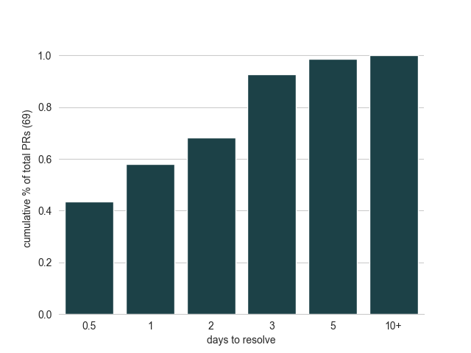

**Figure 8**. Histogram of the time taken to resolve SDEV team’s pull request in the Q1 of 2025.

## Metric #11

|  |  |
| --- | --- |
| Metrics title | **Number of SDev Jira tickets by the tickets’ component** |
| Metric’s purpose | The goal of this metric is to identify the tasks that SDEV group spends its time on in a particular quarter.  Each JIRA ticket is tagged with one or more components. The number of JIRA tickets per component will be counted at the end of each quarter. Only tickets created in the given quarter will be included in the counts. |
| Data | Q1, 2025: January 1 to March 31  This measure is collected using JIRA dashboard and reporting tools. |
| Acceptance Criteria | This metric is an exploratory measure that helps with identifying particular pipelines or tasks that SDEV is spending a disproportionate amount of time and resources developing and/or maintaining. |
| Analysis and Findings | This quarter there were 74 relating to Tumour Characterization pipelines, 64 relating to Primary Analysis pipelines, and 98 that related to other tasks. |

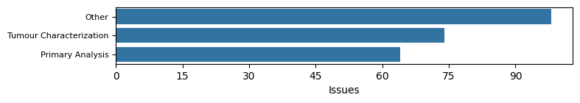

**Figure 9.** Total number of components per analysis type in the Q1 of 2025.

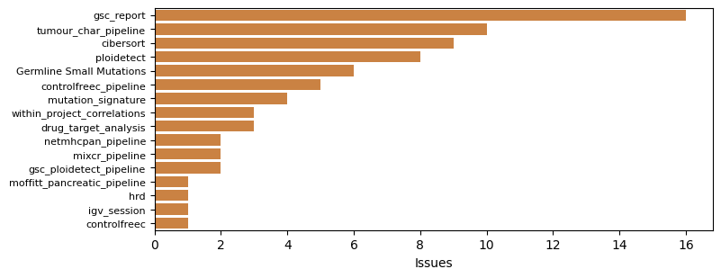

**Figure 10.** Total number of tickets per Tumour Characterization component in the Q1 of 2025.

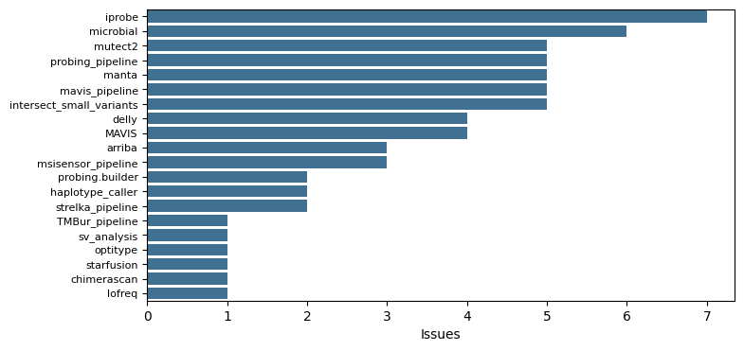

**Figure 11.** Total number of tickets per Primary Analysis component in the Q1 of 2025.

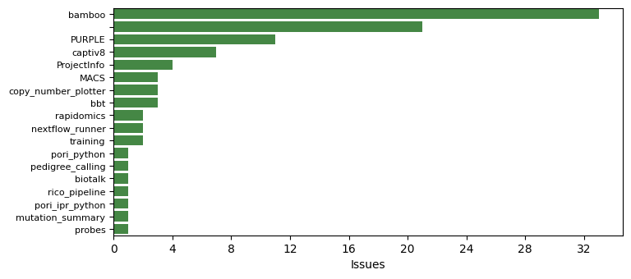

**Figure 12.** Total number of tickets per “Other” component in the Q1 of 2025.

1. **General Conclusions**
   1. **Quarterly Summary**

1. **Quarterly metrics report approval**

|  |  |  |  |
| --- | --- | --- | --- |
| **Group** | **Name** | **Signature** | **Date** |
| SDEV | Caleb Choo |  |  |
| Bioinformatics Production | Karen Mungall |  |  |
| Quality Systems | Miruna Bala |  |  |